

# Star Classes

**Supervisor:** *NGUYỄN HẠ VY*

**Semester:** *01*

**Batch No:** *T1.2302.M0*

**Group No:** *03*

|  |  |  |
| --- | --- | --- |
| **Order:** | **Full name** | **Roll No.** |
| *1.* | *LÊ VĂN KHUYÊN* | Student1455064 |
| *2.* | *PHẠM DUY HẬU* | Student1455769 |
| *3.* | *TRẦN THANH PHONG* | Student1455053 |
| *4.* | *GIANG LÊ PHÚ THỊNH* | Student930334 |

***Month****: 6* ***Year****: 2023*

Acknowledge Synopsis

1. Interactive with Recruiting Website
2. Interactive with Home Page
3. Interactive with Course Website
4. Interactive with About Us Page

V. Interactive with Contact page

VI. Interactive with Cart Page

# Acknowledge

As we understand that the eProject is a step-by-step learning environment that closely simulates the classroom and Lab-based learning environment into actual implementation. It is a project implementation at your fingertips!! An electronic, live juncture on the machine that allows you to.

* Practice step by step i.e. laddered approach.
* Build a larger more robust application.
* Usage of certain utilities in applications designed by user.
* Single program to unified code leading to a complete application.
* Learn implementation of concepts in a phased manner.
* Enhance skills and add value.
* Work on real-life projects.
* Give a real-life scenario and help to create applications that are more complicated and useful.
* Mentoring through email support.

First of all, I would like to thank India Aptech for allowing my team to work on this fantastic eProject. We had a great experience with eProject this time.

Next, We would like to express my special thanks to our mentor, Ms. Ha Vy for the time and effort that she provided throughout the project. Your helpful advice and suggestions were beneficial to us during the completion of the project. In this respect, We are forever grateful to you.

Besides several mistakes we made in the project, we hope to have more opportunities to widen our knowledge in the web-developing world.

We will try to continue to learn and improve ourselves even more in the future.

Yours Sincerely,

Team Group 02.

# Synopsis

The Objective of this program we aim is to give a sample project to work on real- life projects. These applications help us build a larger more robust application.

The objective is not to teach us HTML/JavaScript but to provide us with a real-life scenario and help us create basic applications using the tools.

Hence, we can revise the chapters before we start with the project.

This project is meant for students like us who have completed the module of HTML5. These programs should be done in the Lab sessions with the assistance of the faculty if required.

The website (in this project) is a tool that brings everything in the world to you such as historic monuments information natural knowledge and skill in technology...

It is very essential for us that will have a clear understanding of the subject. We think we should go through the project and solve the assignments as per the requirements given.

And get back [***eprojects@aptech.ac.in***](mailto:eprojects@aptech.ac.in) as the assigned schedule.

## Problem Definition

Star Classes is into business for more than a decade. They have been advertising specializing in about their coaching classes through newspapers, pamphlets, television. Now with

changing times, they have decided to go online as most of the students today are frequent users of Internet. They have planned for a website with complete details about the Coaching classes.

You are supposed to create a Single-Page-Application and responsive Website for them with the below mentioned requirement specifications.

The website is to be developed for the Windows Platform using HTML5, JavaScript butter, and Geolocation. The site should work well in all leading browsers including Chrome,

IE, Firefox etc.

*Our Motto: Where smiles are served daily.*

**Requirement Specification:**

The Web site is to be created based on the following requirements.

1) The Top of the Page should have suitable logo, and decent colour

combination.

2) Information should be neatly placed at suitable location.

3) Various sections having information about different courses/subjects taught at

the classes, Faculty/Teachers complete information and previous year’s

success stories should be listed.

4) The site should display a menu which will contain the options for brief

introduction about the above mentioned information, location/address of the

coaching classes and any other information if required.

5) The information should be categorized according to different subjects like if a

User wants to see details of ‘Commerce’ then he click on a Link/button/menu

etc and he will see details of course structure of commerce. Similarly for

‘Mathematic’, ‘Languages’ and other subjects. Proper Filter Options should be

available.

6) When a user selects any course stream, complete list of subjects for that

course stream will be displayed.

7) Details of the courses should be displayed on the Web Page along with the

title and it should be available for download.

8) Price List for all courses should be available for download.

9) There should be a “Contact Us” section which will have the Address of the

Coaching Classes and the mail address which when clicked will invoke the

local mail client from where they can send an email. Address of the Company

should be displayed using GeoLocation API (eg. GoogleMaps).

Over and above this, the portal should implement the following functionalities:

* Display a continuous scrolling ticker at the bottom of the page with current date, time, and location (hint: Use geolocation features of HTML5).
* Display a visitor count at the top right corner of the page beside a logo image.
* The menu options should change color on hover and also after clicking.
* Fade in and fade out options can be used for the menus.

## Customer Requirements Specifications

**CSS from w3schools:**

**<link rel="stylesheet" href="https://www.w3schools.com/w3css/4/w3.css">**

**Swiper CSS:**

**<link rel="stylesheet" href="https://cdn.jsdelivr.net/npm/swiper@9/swiper-bundle.min.css"/>**

**FontAwesome Icon CSS:**

**<link rel="stylesheet" href="https://cdnjs.cloudflare.com/ajax/libs/font-awesome/6.4.0/css/all.min.css" integrity="sha512-iecdLmaskl7CVkqkXNQ/ZH/XLlvWZOJyj7Yy7tcenmpD1ypASozpmT/E0iPtmFIB46ZmdtAc9eNBvH0H/ZpiBw==" crossorigin="anonymous" referrerpolicy="no-referrer" />**

**Ionicons ES Module Script:**

**<script type="module" src="https://unpkg.com/ionicons@7.1.0/dist/ionicons/ionicons.esm.js"></script>**

**Ionicons Script:**

**<script nomodule src="https://unpkg.com/ionicons@7.1.0/dist/ionicons/ionicons.js"></script>**

**Bootstrap CSS:**

**<link href="https://cdn.jsdelivr.net/npm/bootstrap@5.3.0-alpha3/dist/css/bootstrap.min.css" rel="stylesheet" integrity="sha384-KK94CHFLLe+nY2dmCWGMq91rCGa5gtU4mk92HdvYe+M/SXH301p5ILy+dN9+nJOZ" crossorigin="anonymous">**

**Bootstrap Bundle Script:**

**<script src="https://cdn.jsdelivr.net/npm/bootstrap@5.3.0-alpha3/dist/js/bootstrap.bundle.min.js" integrity="sha384-ENjdO4Dr2bkBIFxQpeoTz1HIcje39Wm4jDKdf19U8gI4ddQ3GYNS7NTKfAdVQSZe" crossorigin="anonymous"></script>**

**jQuery Slim:**

**<script src="https://code.jquery.com/jquery-3.3.1.slim.min.js" integrity="sha384-q8i/X+965DzO0rT7abK41JStQIAqVgRVzpbzo5smXKp4YfRvH+8abtTE1Pi6jizo" crossorigin="anonymous"></script>**

**Popper.js:**

**<script src="https://cdn.jsdelivr.net/npm/popper.js@1.14.7/dist/umd/popper.min.js" integrity="sha384-UO2eT0CpHqdSJQ6hJty5KVphtPhzWj9WO1clHTMGa3JDZwrnQq4sF86dIHNDz0W1" crossorigin="anonymous"></script>**

**Ionicons CSS:**

**<link rel="stylesheet" href="https://code.ionicframework.com/ionicons/2.0.1/css/ionicons.min.css" />**

**Twitter Bootstrap CSS:**

**<link rel="stylesheet" href="https://code.ionicframework.com/ionicons/2.0.1/css/ionicons.min.css" />**

#### Process:

* Design and develop a Single-Page-Application (SPA) architecture for the website.
* Implement responsive web design principles to ensure compatibility with different devices and screen sizes.
* Use HTML5 to structure the website's content and incorporate modern features and functionality.
* Utilize JavaScript for client-side interactivity and dynamic behavior.
* Incorporate Geolocation functionality to provide location-based services or information.

#### Output:

* Display comprehensive information about the coaching classes and gym classes, including courses offered, faculty details, class schedules, pricing, and contact information.
* Ensure the website is visually appealing, user-friendly, and accessible on various devices.
* Support smooth navigation and seamless user experience across different browsers.
* Leverage the features and capabilities provided by HTML5, JavaScript, and Geolocation to enhance the website's functionality and user interaction.

### Hardware/ software requirement:

#### Software:

* + Notepad/HTML editor
  + Dreamweaver
  + IE 5.0/ Netscape 6.0

#### Hardware:

* + A minimum computer system that will help you access all the tools in the courses is a Pentium 166 or better
  + 64 Megabytes of RAM or be

Home

User

About Us

Contact Us

Recruitment

Course

Current

Openings

Classes detail

Recruitment

Specialist

Recruitment

Specialist

Feedback and Message

Buy a course

Overview

class course

Detail about teachers

instructor

Location

Last year story

Login

Register

1. Interactive with Recruiting Website

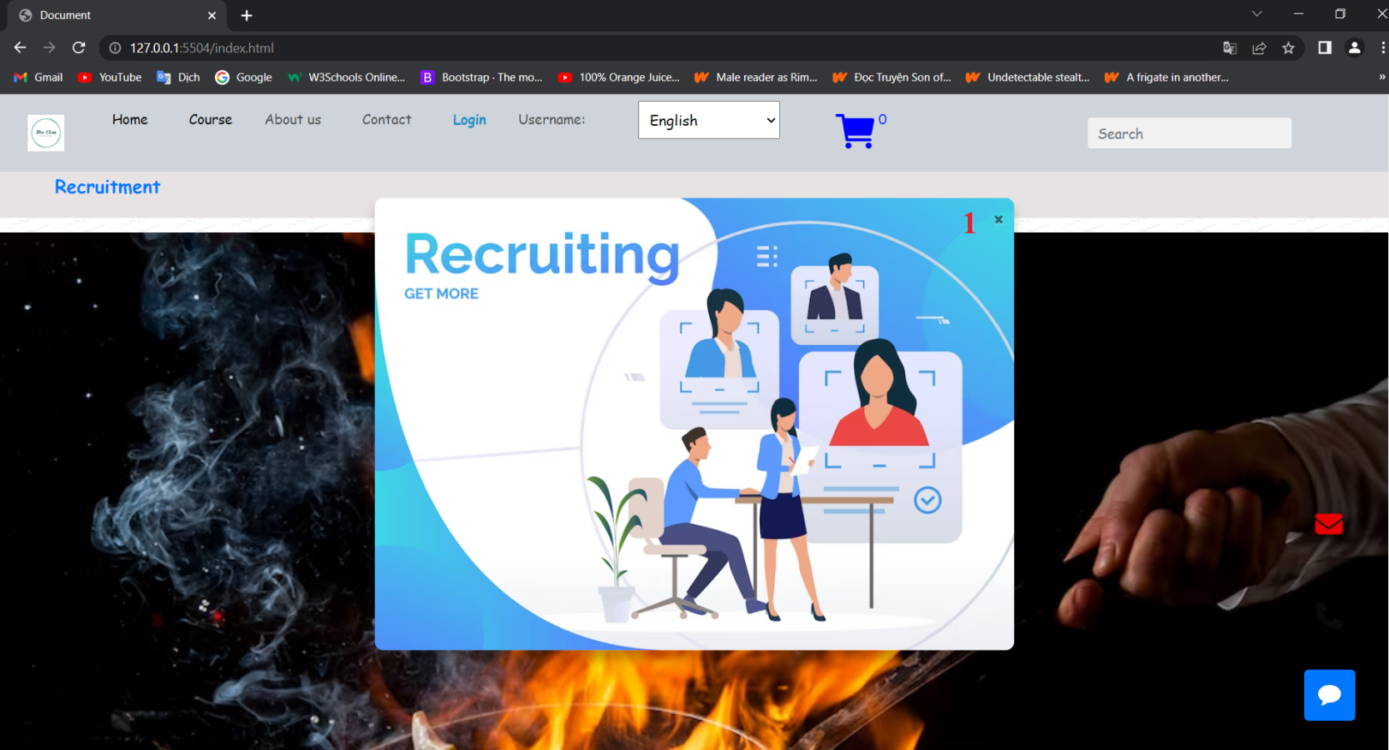

|  |  |
| --- | --- |
| 1 | “**x**” is delete popup, or click the picture to open the “**Recruitment**” |

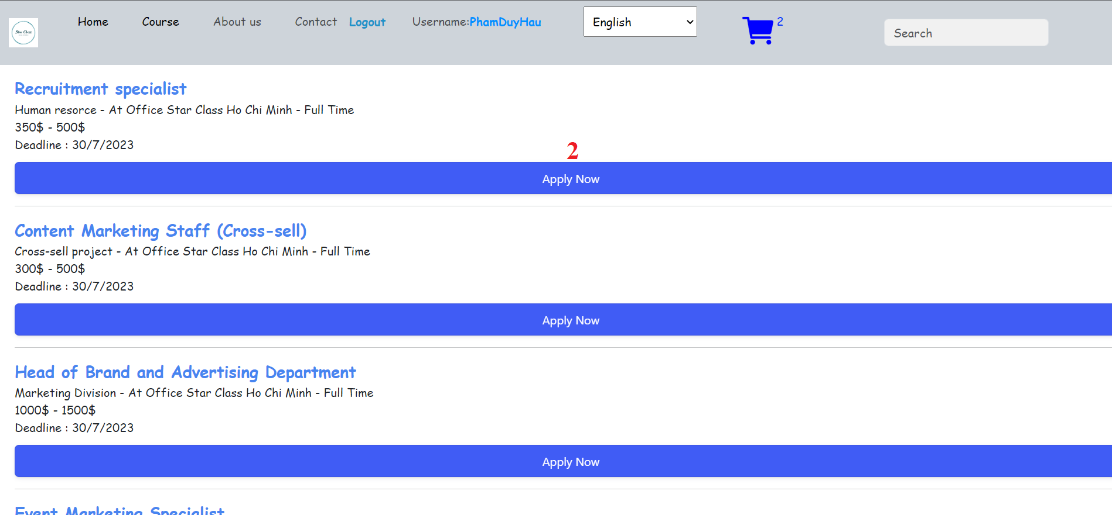

|  |  |
| --- | --- |
| 2 | Click “Apply Now” to open website register |

|  |  |
| --- | --- |
| 3 | * This section here is for Applicaton form. You need to add name, Email Address, Phone, and picture to submit. * If you don’t Fill all the form alert “Fill All Form” * If succes alert “Thank you for submitting” |

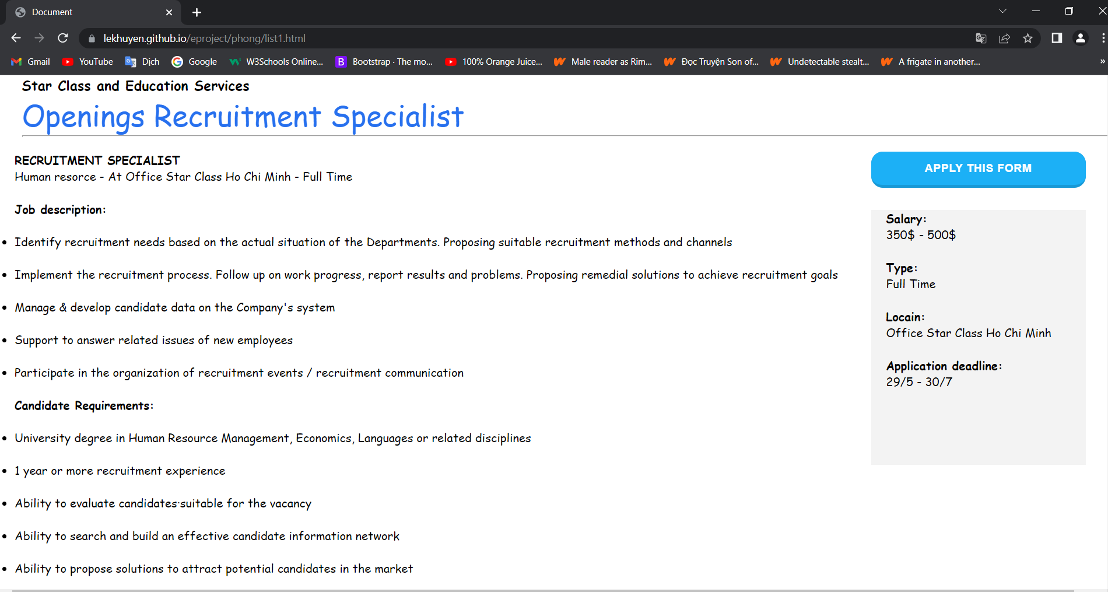

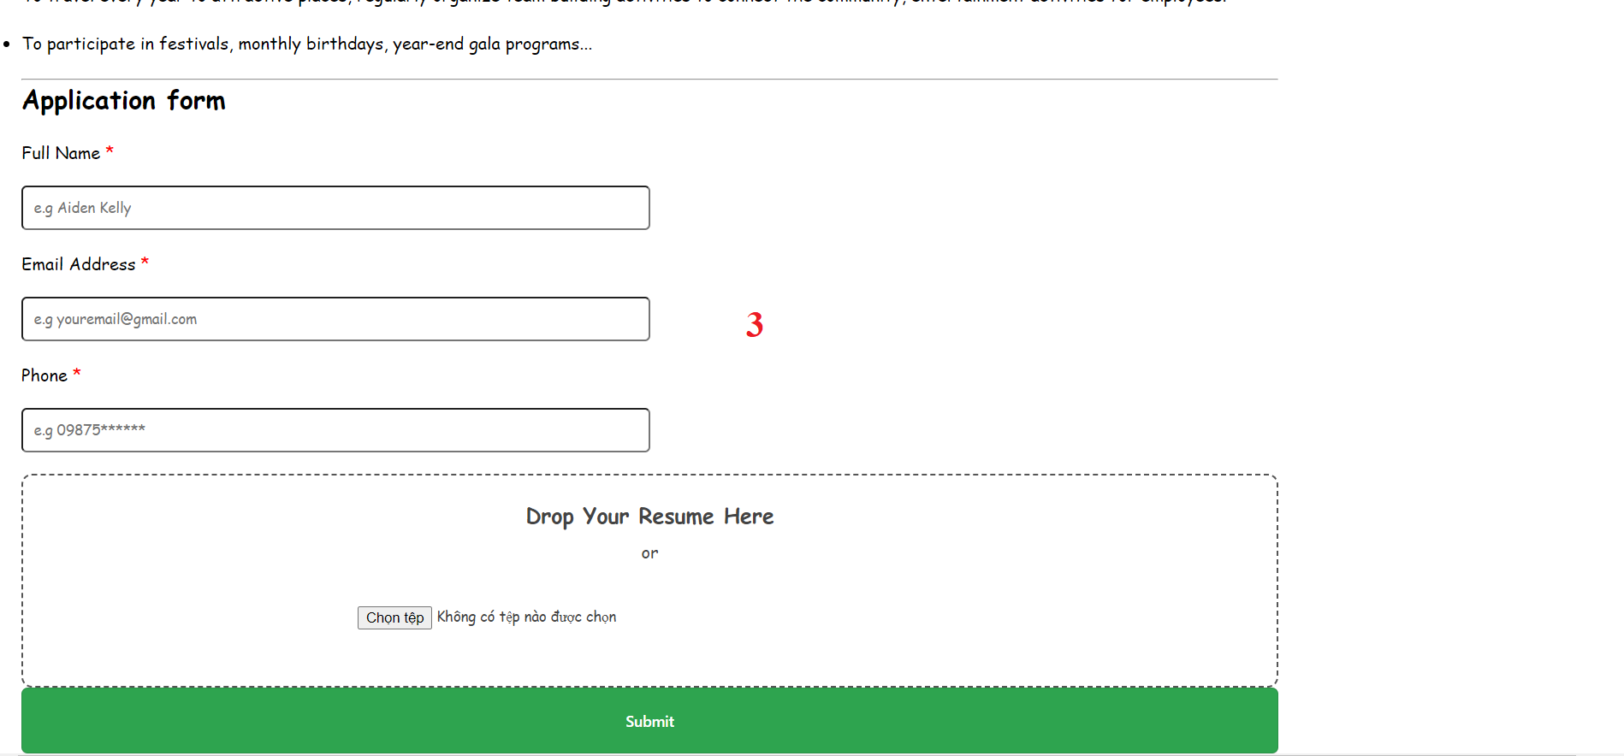

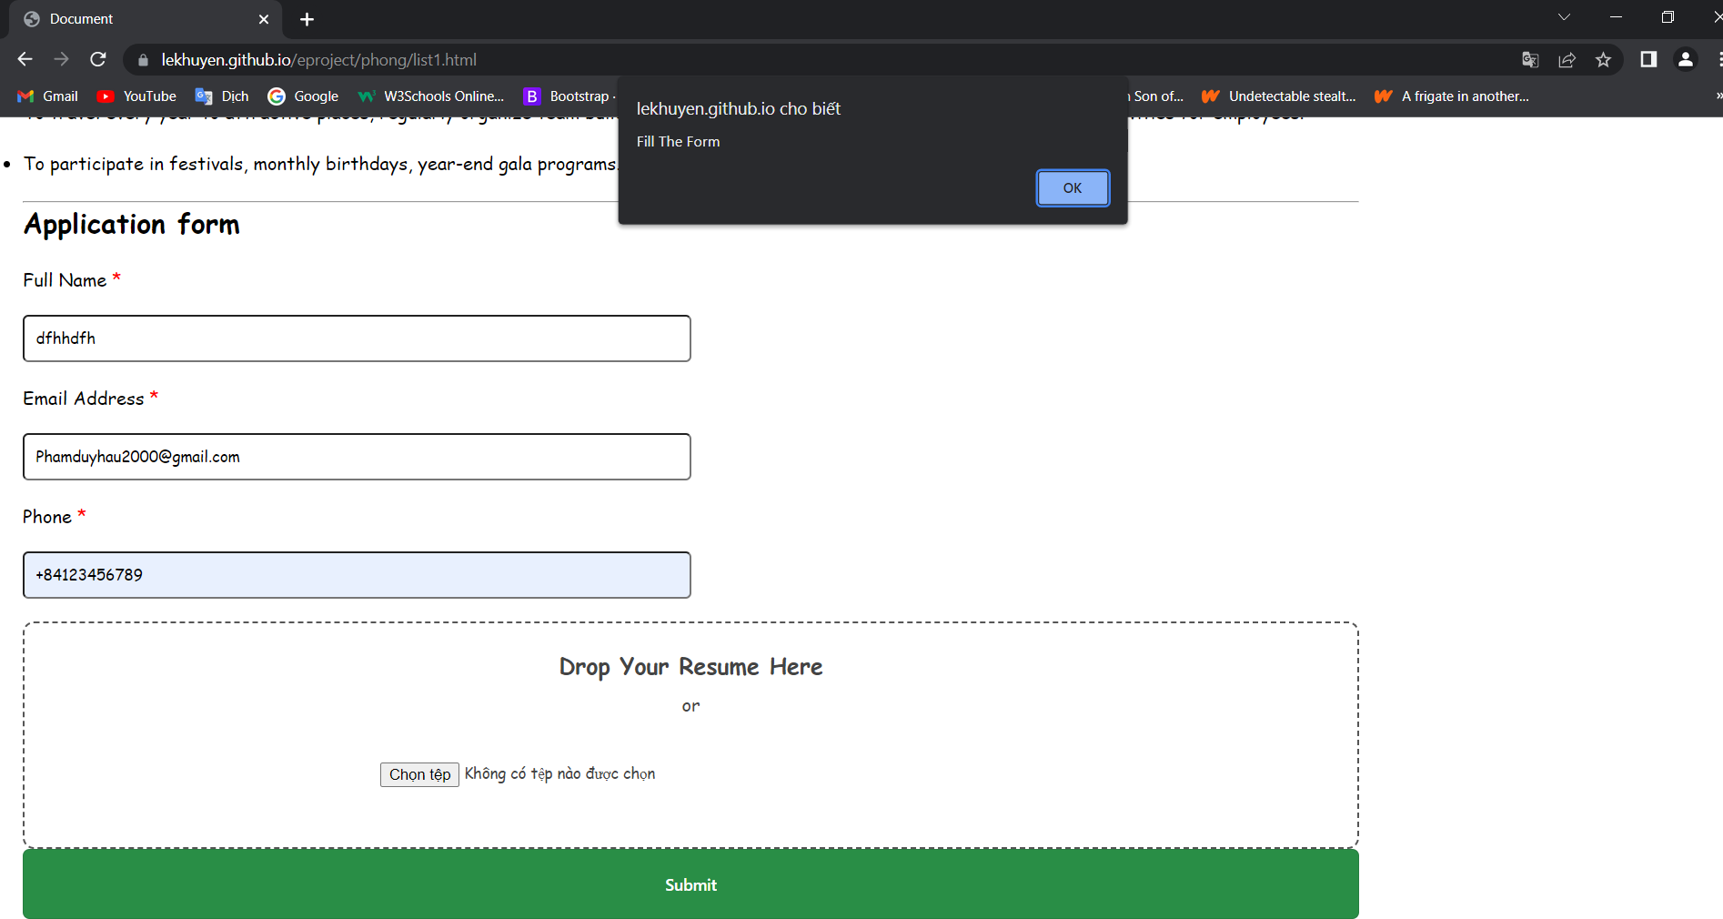

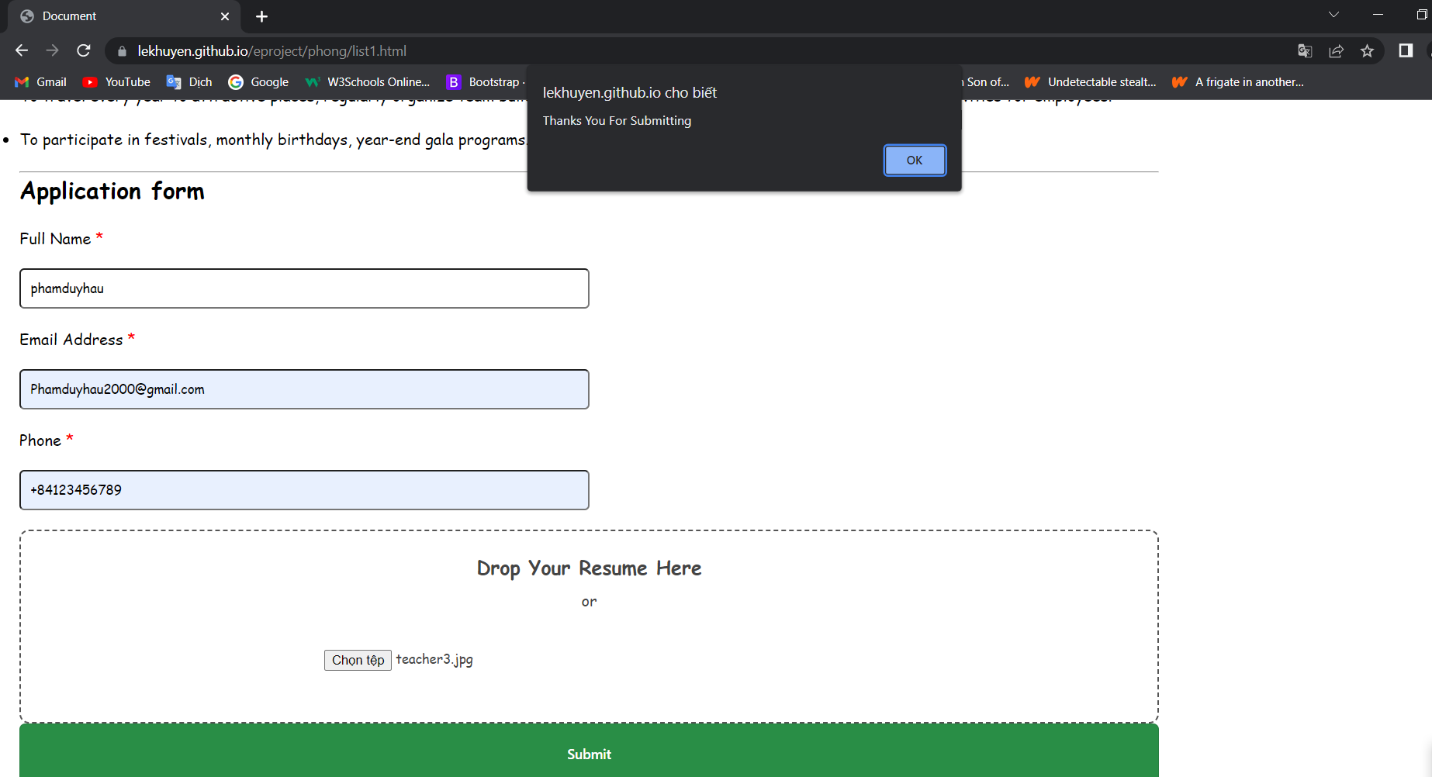

1. Interactive with Home Page

|  |  |
| --- | --- |
| 1 | Click “home” will return main page “home”. |
| 2 | Click “Course” will open “course” website. |
| 3 | Click “About us” will open “about us” website. |
| 4 | Click “Contact” will open “Contact” website. |
| 5 | Click “Login” will open “Login” website. |
| 6 | Show your name when you login and register |
| 7 | Option To change your language “VietNam,English,Hindian” |
| 8 | Click icon “Cart” will open “cart” website. |
| 9 | Search course name and then click will open website course |
| 10 | Click “Recruitment” will open “Recruiment” website. |
| 11 | Click each “Cards” will open website filter course. |
| 12 | Click “View All Categroies” will open “Course” website. |

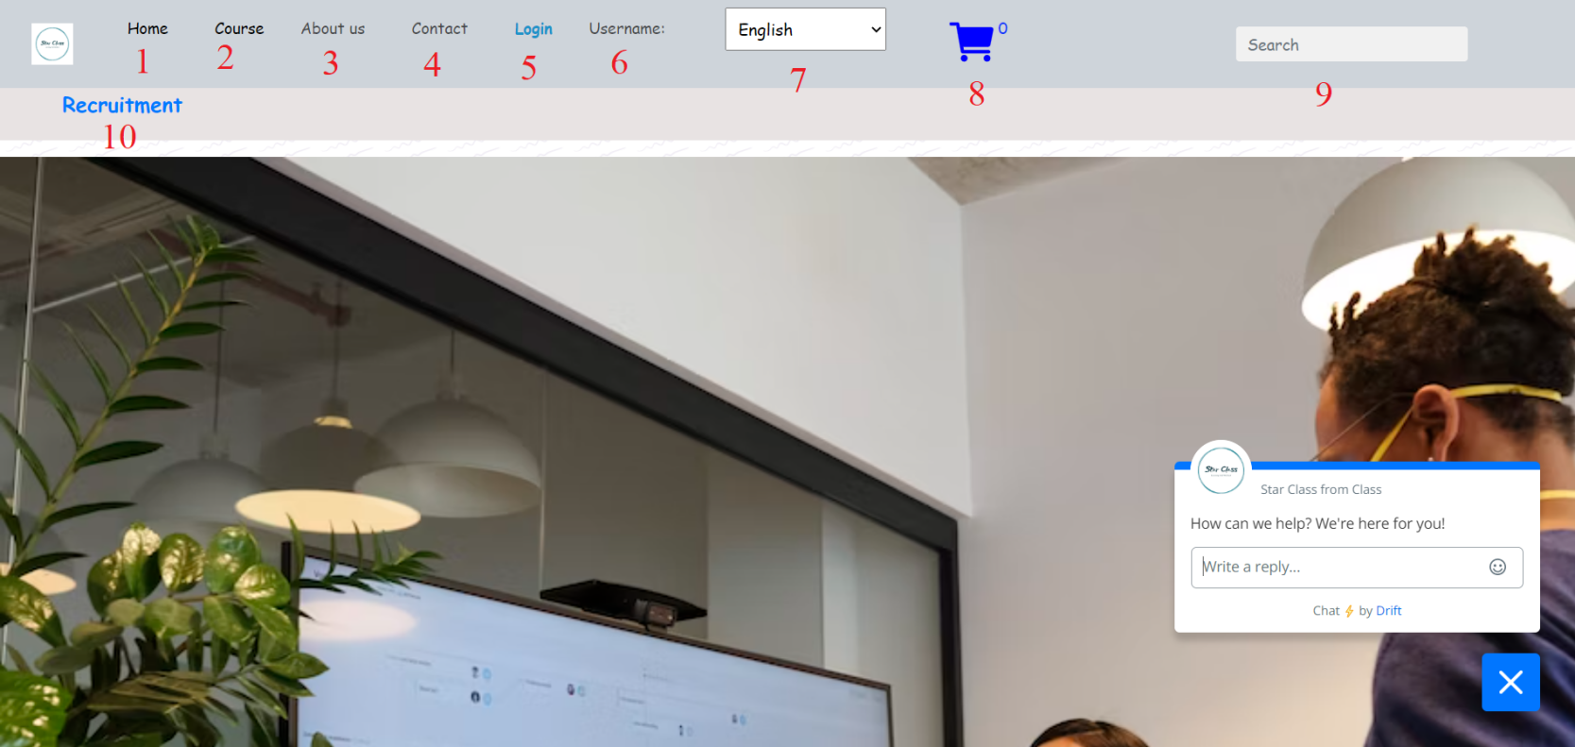

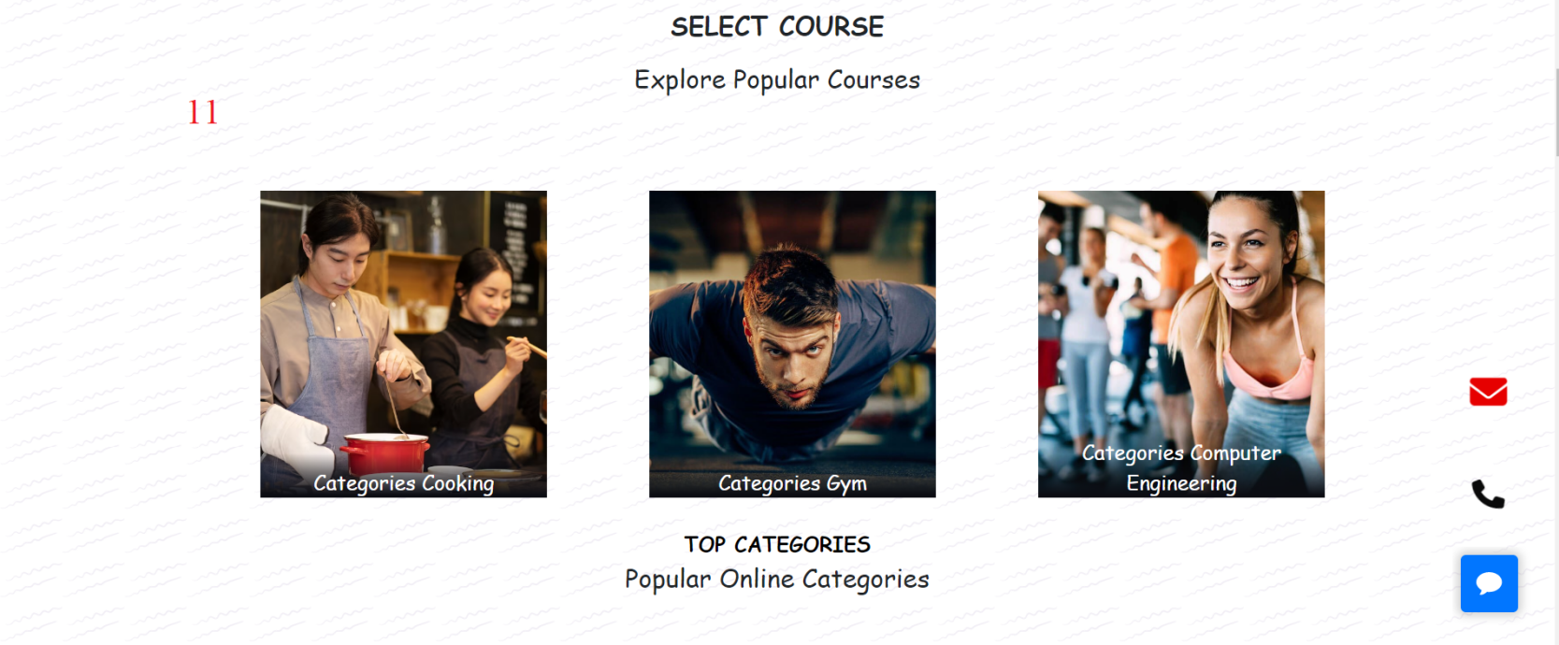

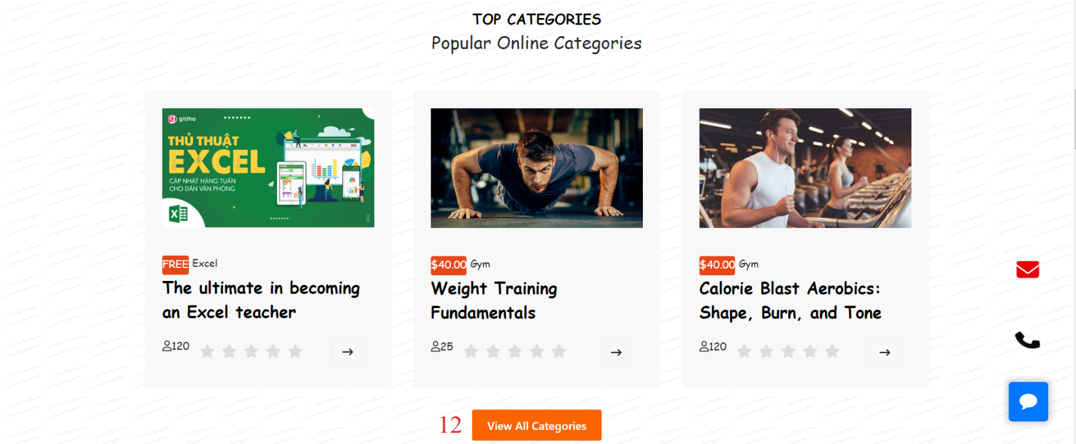

|  |  |
| --- | --- |
| 13 | Click “Register Now” will open popup register form. |
| 14 | You need to fill all the form to press button Submit is form have fill alert “Success!”.  Button “Reset All” for reset all the form. |



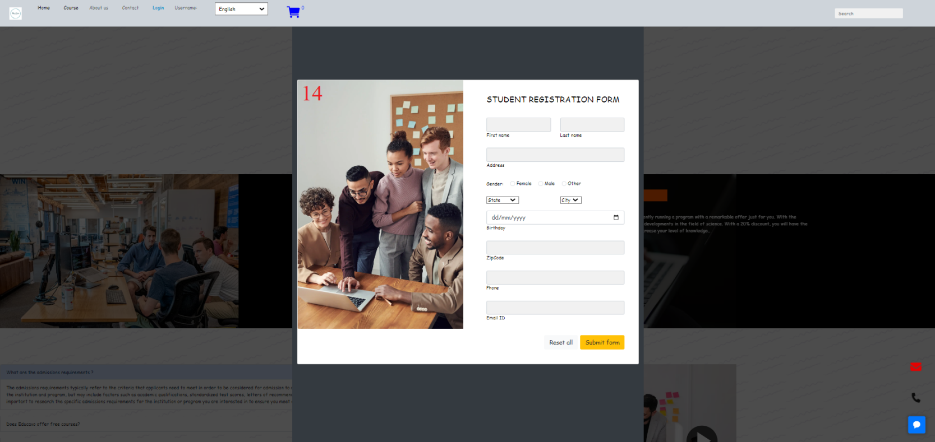

|  |  |
| --- | --- |
| 15 | If you click each item will show you the answer |
| 16 | If you click button “play” will popup a video |

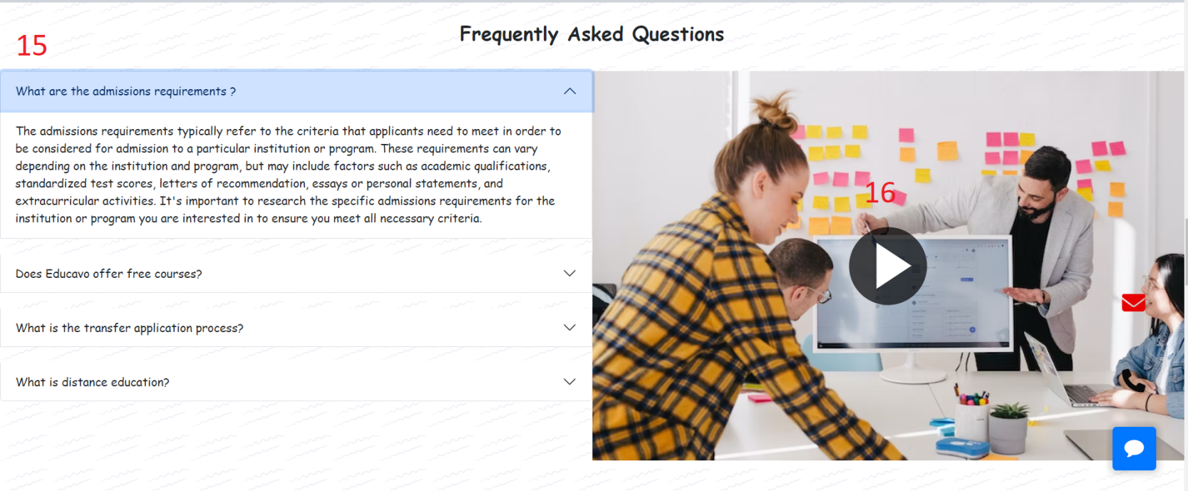

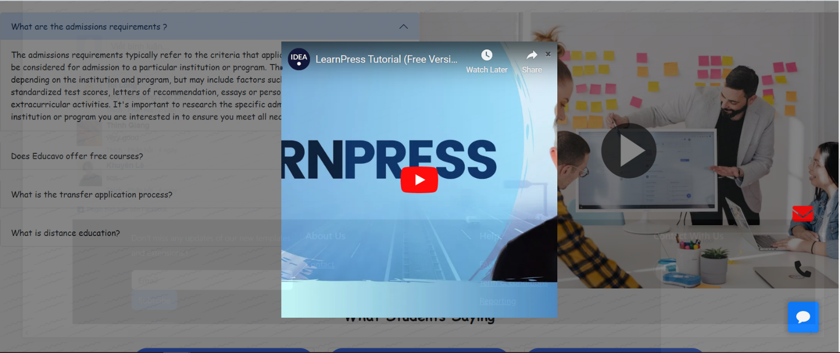

|  |  |
| --- | --- |
| 17 | Click icon “>” button next to see other people reply |

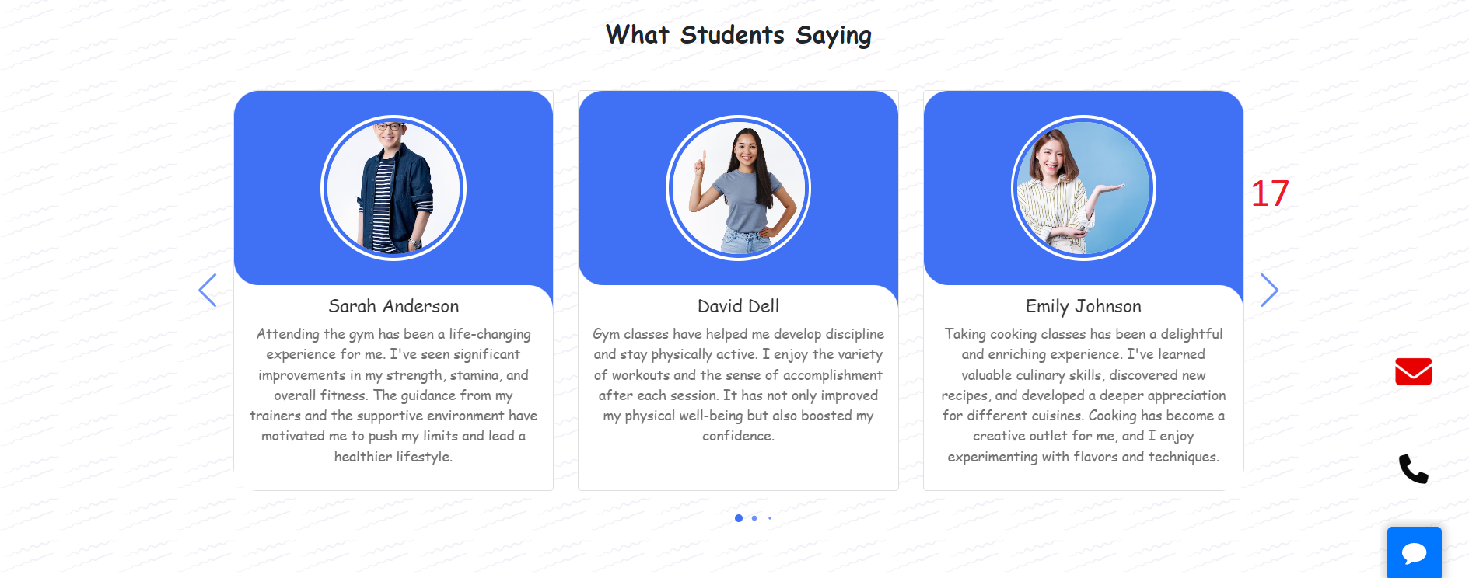

|  |
| --- |
| Classroom pictures show you about the people learning |

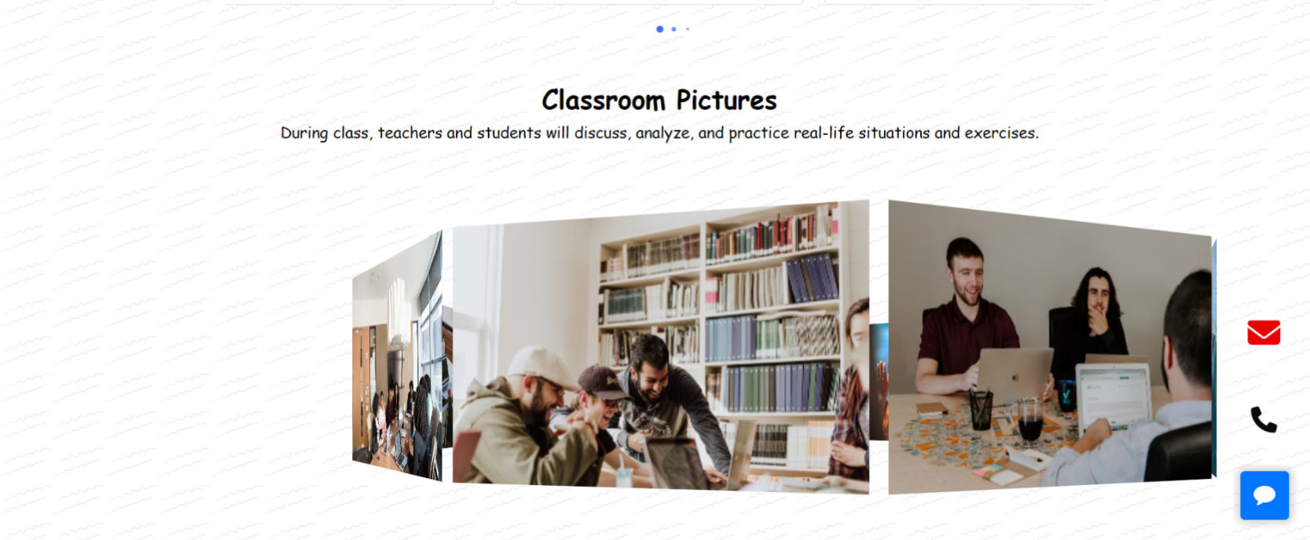

|  |
| --- |
| This comment for people feedback or state your feelings |

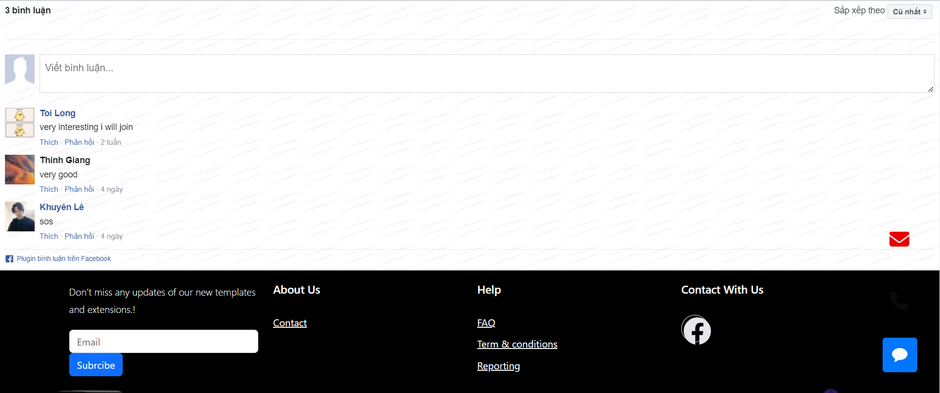

|  |  |
| --- | --- |
| 18 | Click “Contact” will open “contact” website. |
| 19 | Click “Term & conditions” will open “term & conditions” website. |
| 20 | Click icon “F” button “Facebook” will open “Facebook” website. |

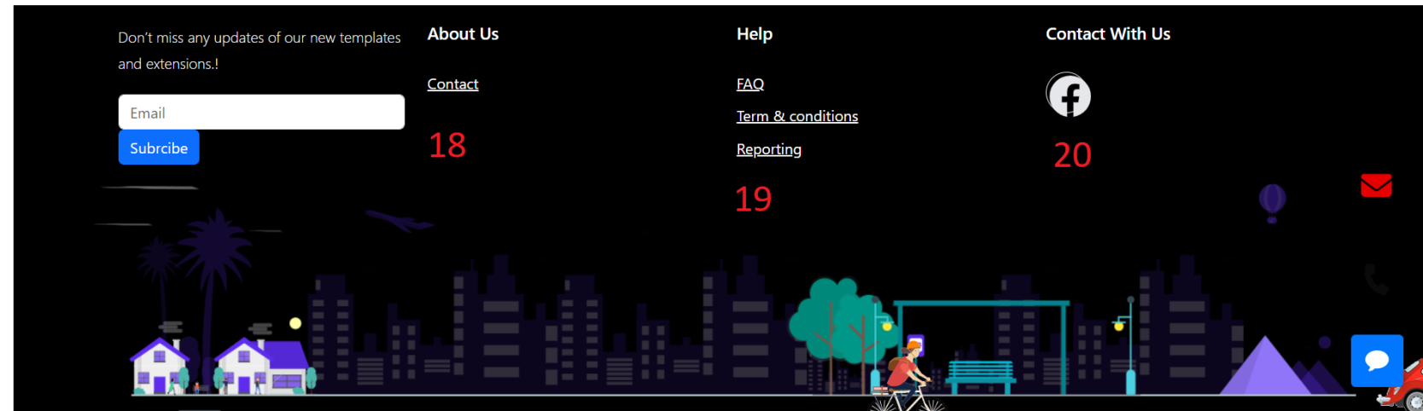

|  |  |
| --- | --- |
| 21 | Click icon “chat” to open popup chatbox |
| 22 | Click icon “phone” to open call |
| 23 | Click icon “email” to open mail |

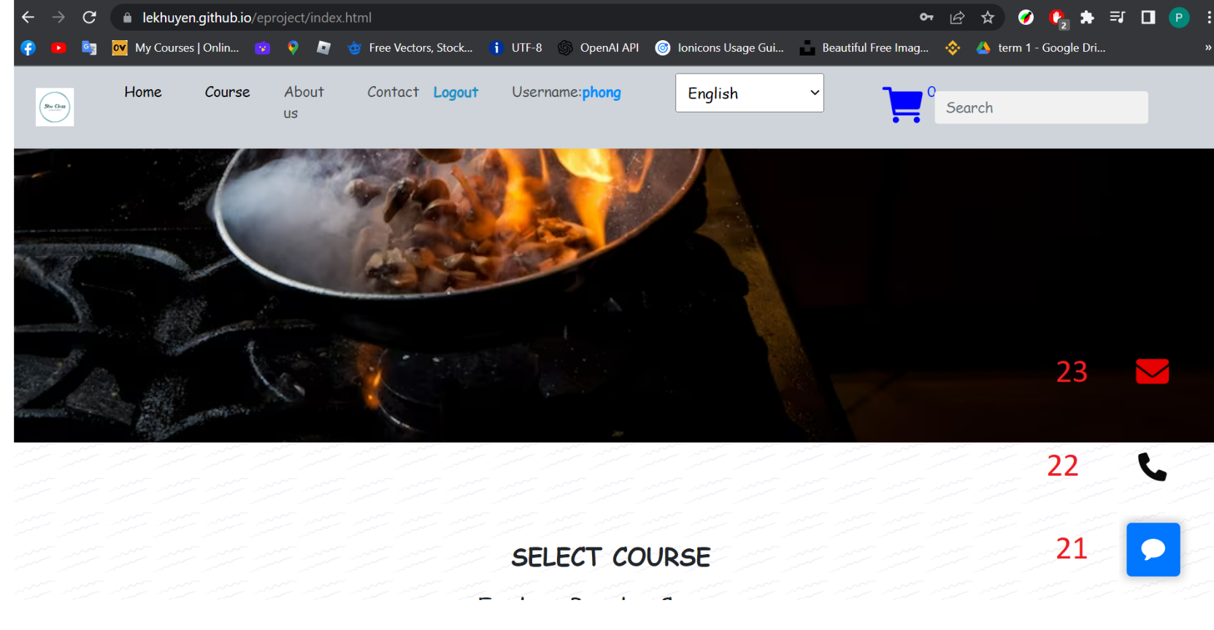

|  |  |
| --- | --- |
| 24 | Click “username” to select your options ( Only work when you login). |
| 25 | Click “Change Password” will open popup “change password”. |
| 26 | Click “Change Name” will open popup “change name”. |
| 27 | Click “Change Avatar” will open popup “change avatar”. |

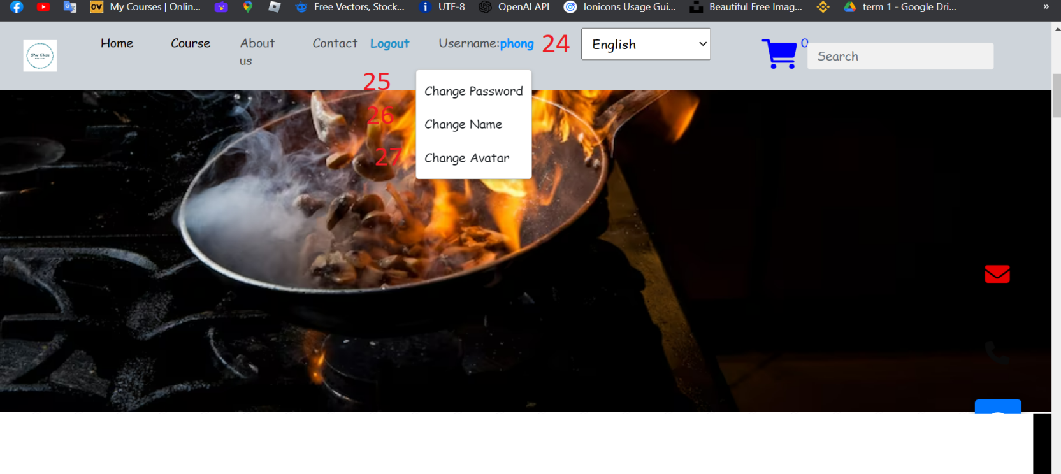

ChangePassword:

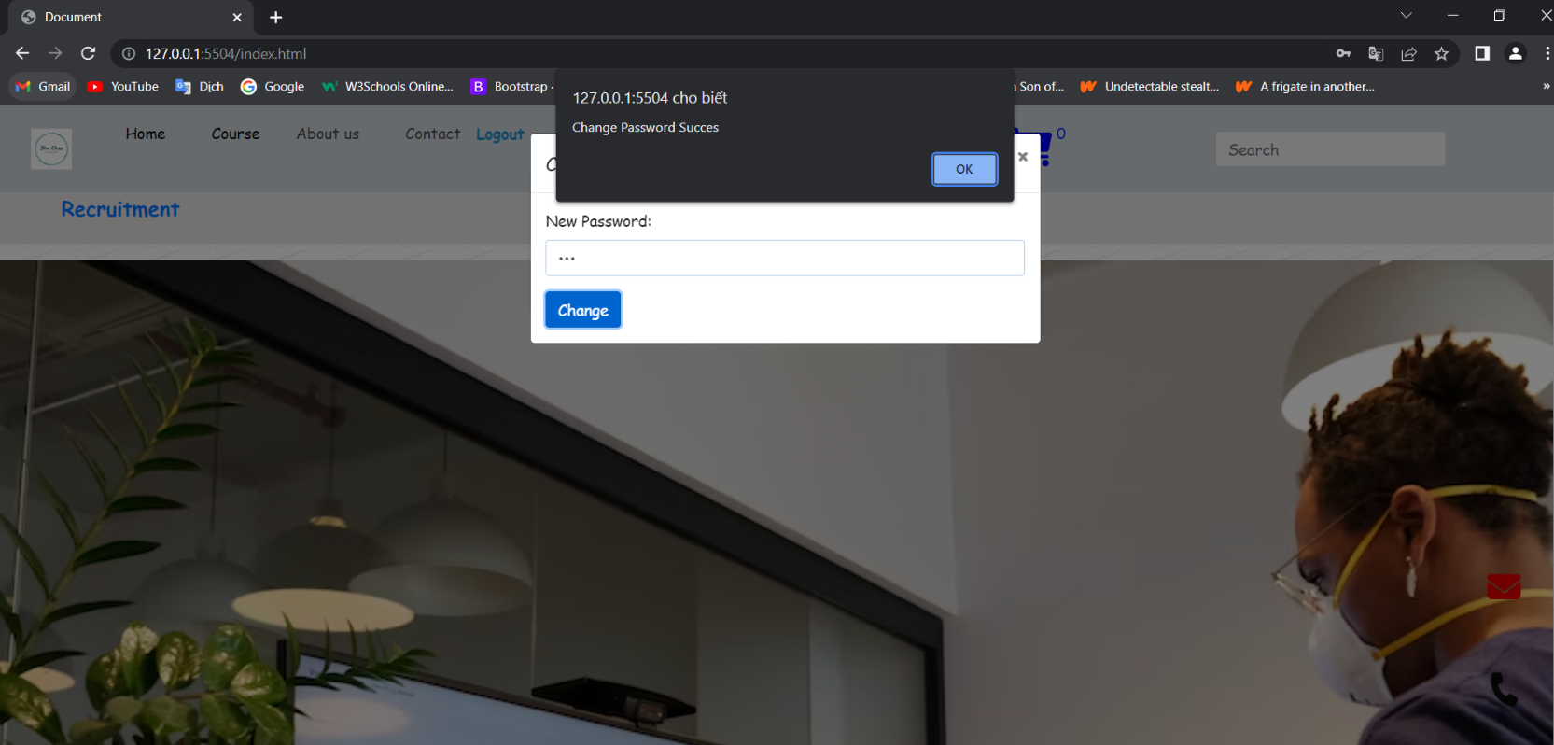

ChangeName: 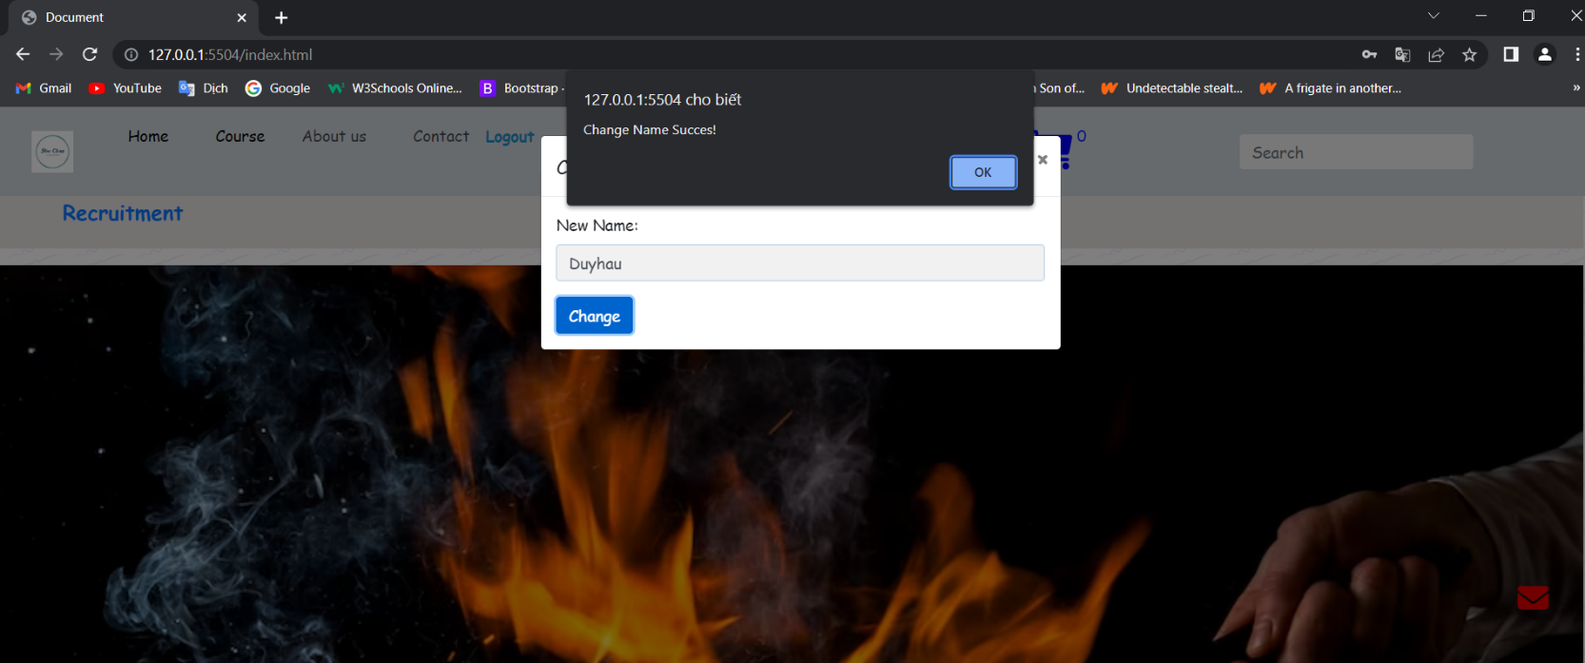

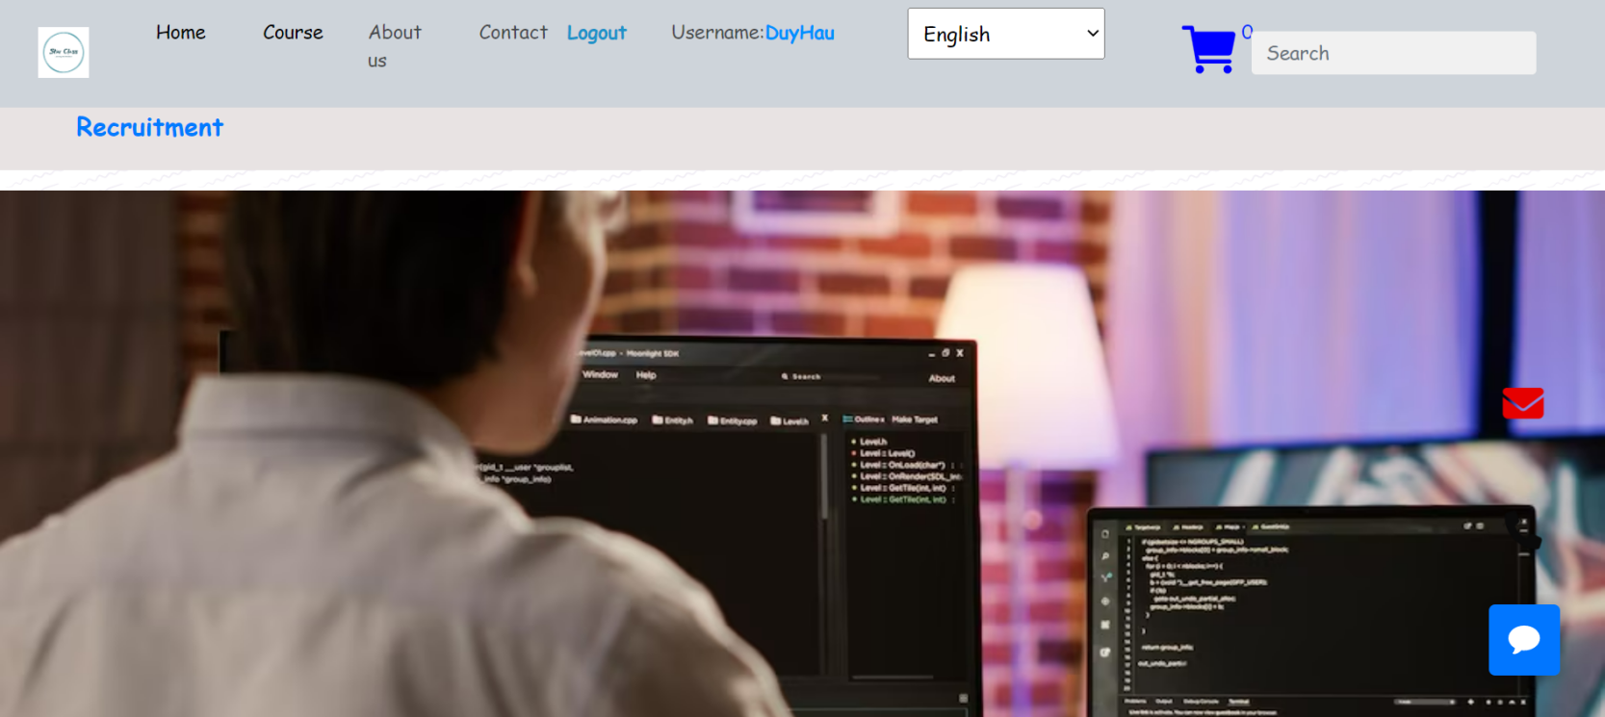

ChangeAvatar:

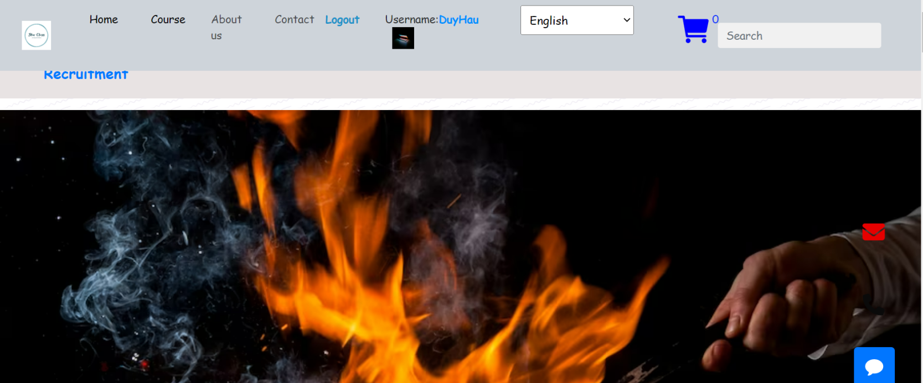

1. Interactive Course Page

|  |  |
| --- | --- |
| 28 | Click “Home” will return to “home”. |
| 29 | Search “Course: (Gym,Excel,Cooking,Developer)” to filter course. |
| 30 | Click “Picture” or “Text” will open “Introduce course” website. |
| 31 | Click icon “Star” to rating. |

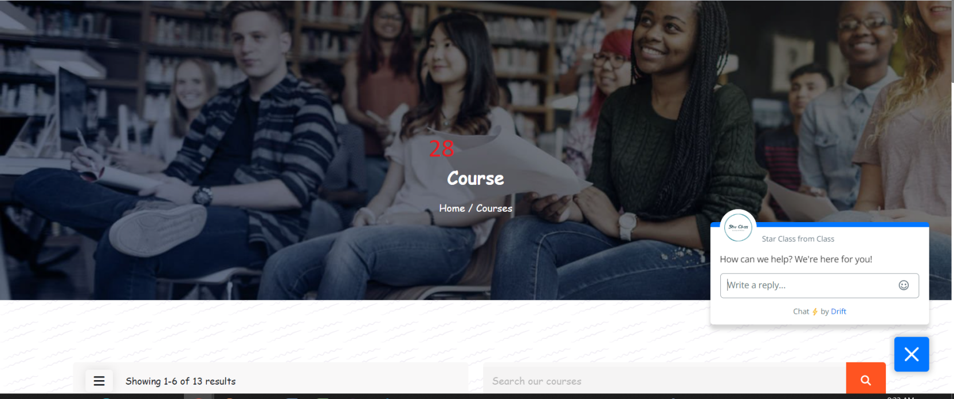

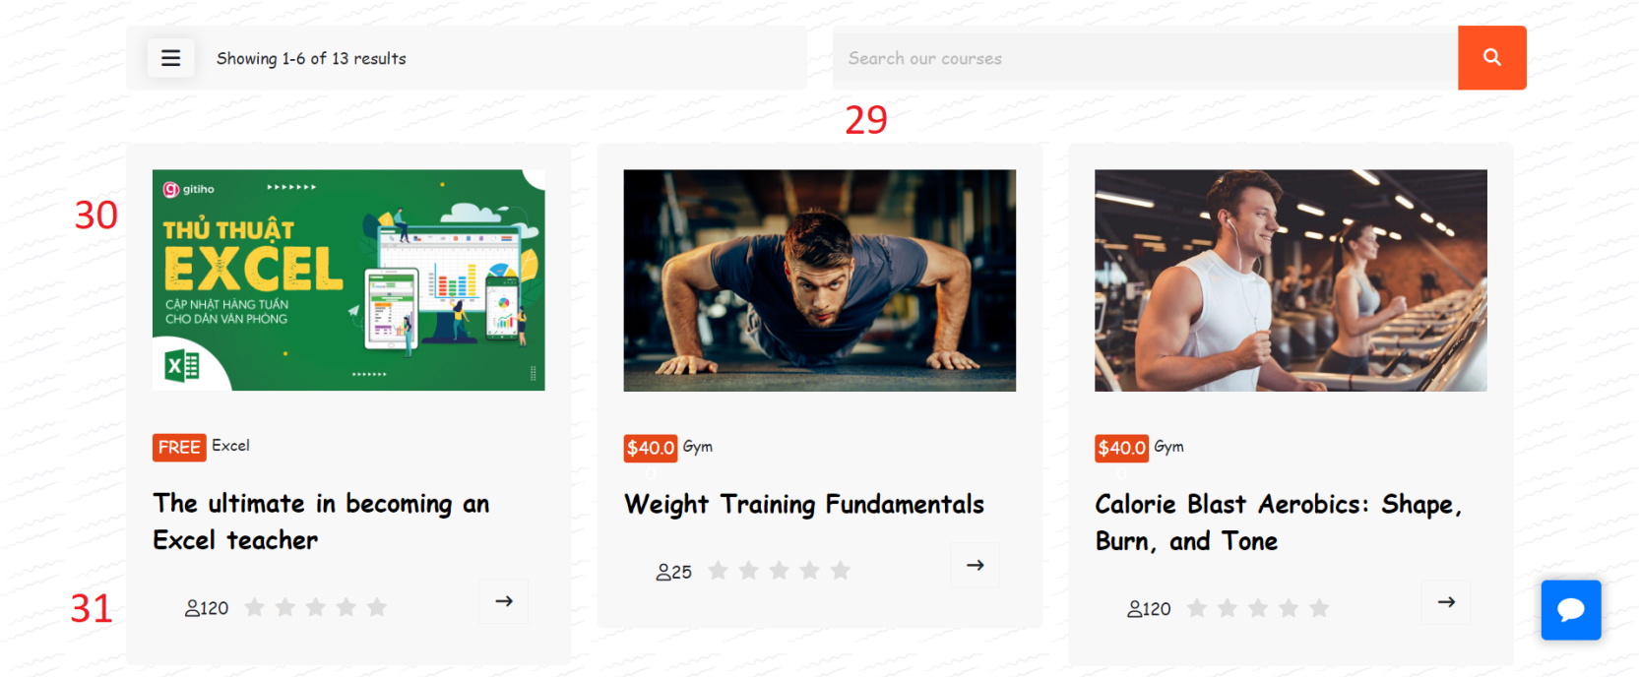

|  |  |
| --- | --- |
| 32 | Click “Overview” to see interview about that course |
| 33 | Click “Curriculum” to see lession that course |
| 34 | Click “Instructor” to see the teacher teach that course |
| 35 | Click “Reviews” to see other people reviews |

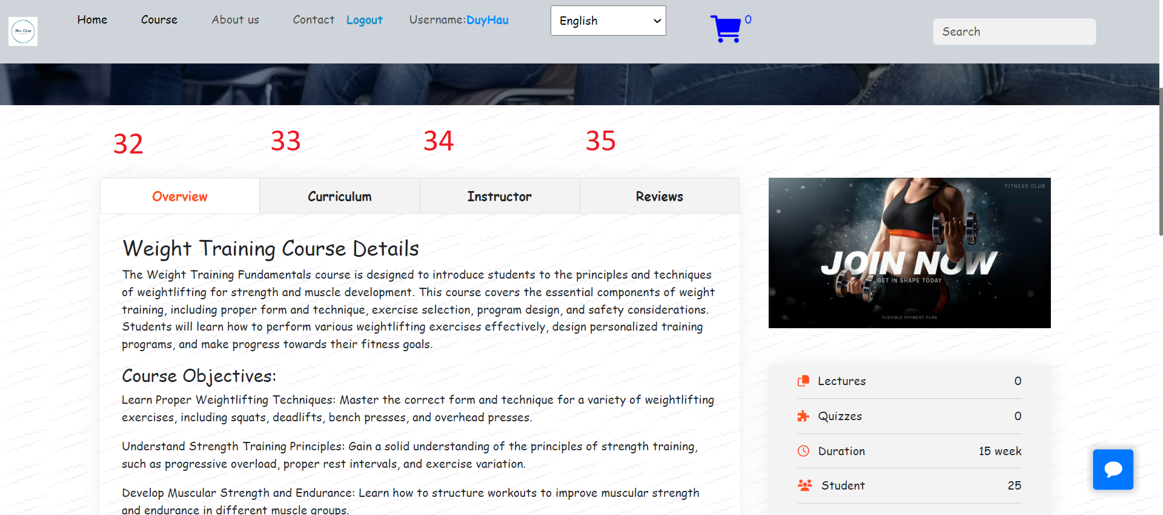

Curriculum:

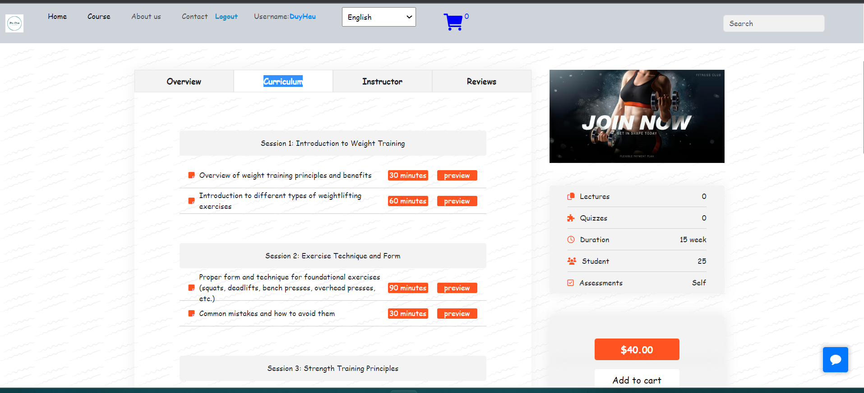

Instructor:

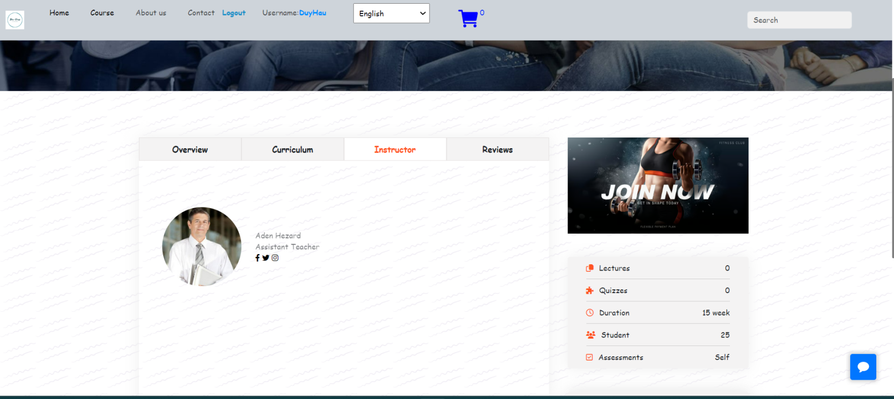

Reviews:

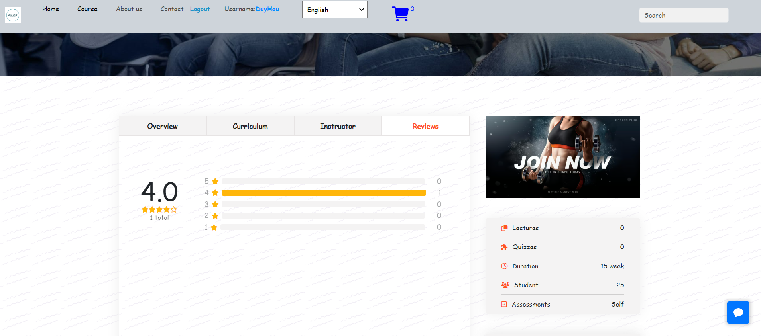

|  |  |
| --- | --- |
| 37 | Click “Add to cart” Course you add will move to cart. |

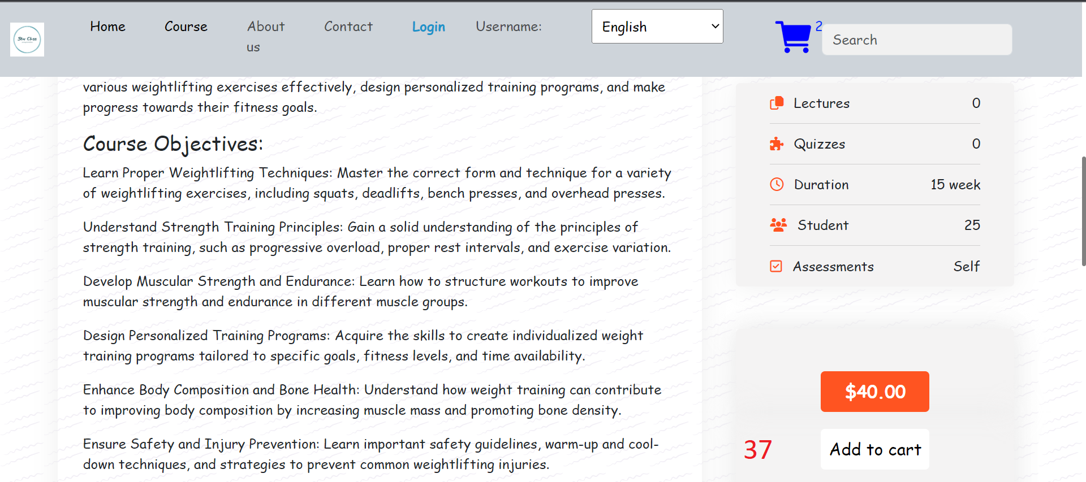

|  |  |
| --- | --- |
| 38 | Click “Number” Or “Next” to see other course |

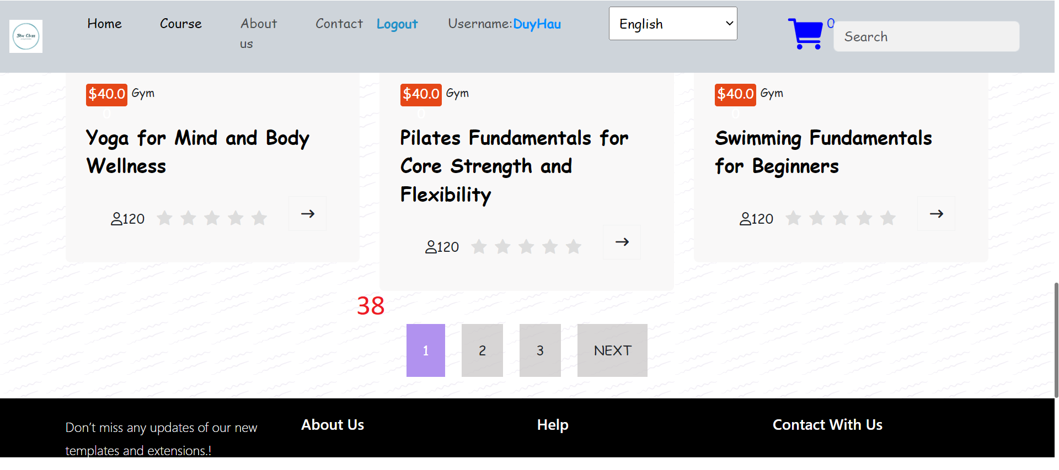

IV. Interactive About Us Page

|  |
| --- |
| This Page Introduce About Us |

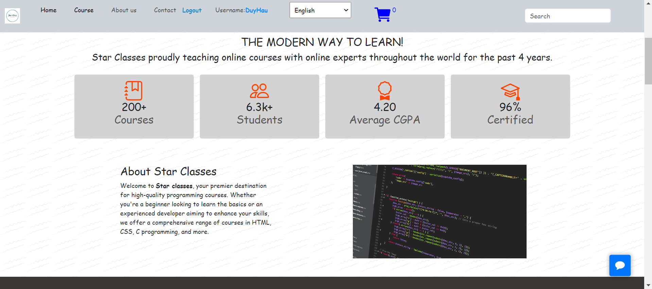

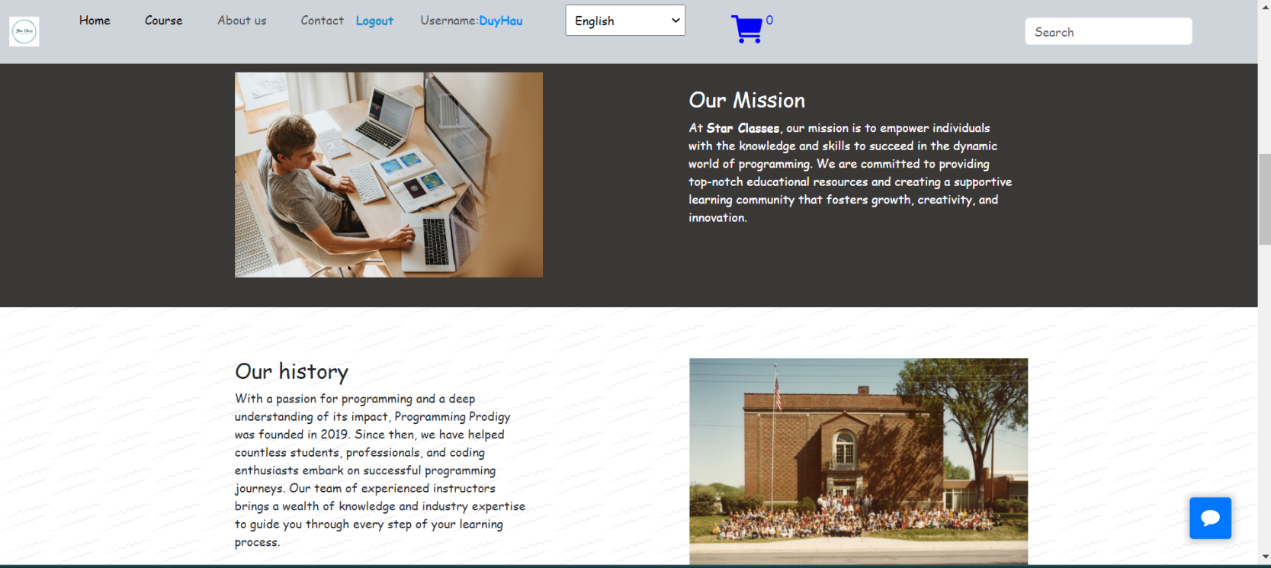

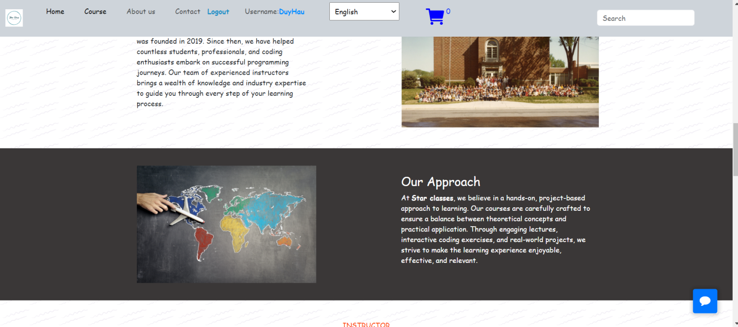

Scroll down we have information techer:

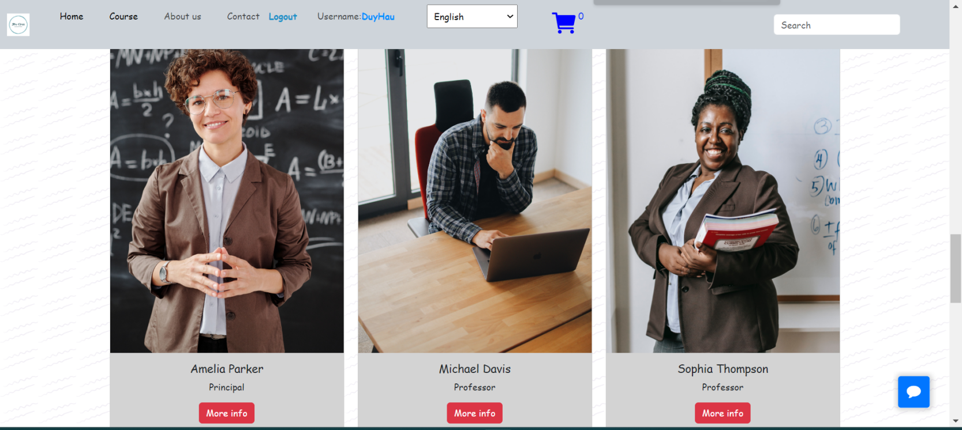

|  |  |
| --- | --- |
| 39 | Click “More Info” will open introduce that teacher |

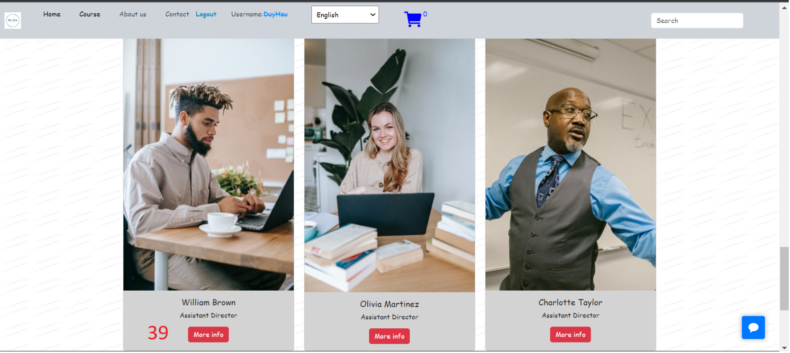

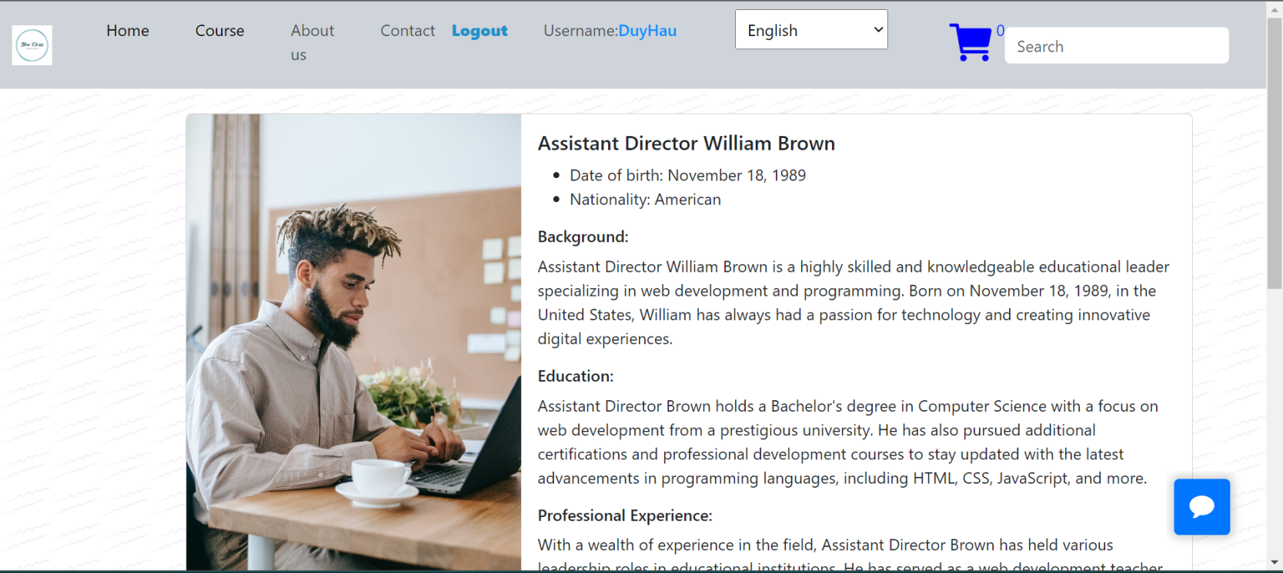

V. Interactive Contact page

|  |  |
| --- | --- |
| 40 | Click “email” to show up mail talk with us |
| 41 | Click “phone” to show up phone talk with us |

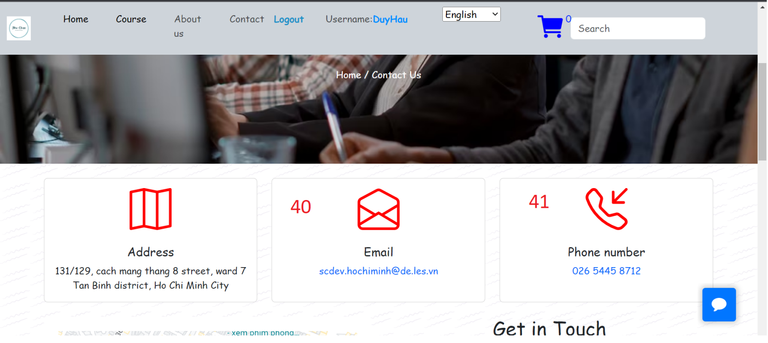

|  |
| --- |
| Get In Touch: Fill out the form and then we can be in touch. Our address is shown on the map. |

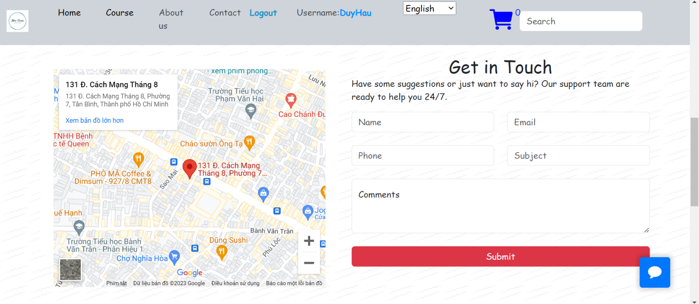

VI. Interactive Cart Page

When cart is empty this background display

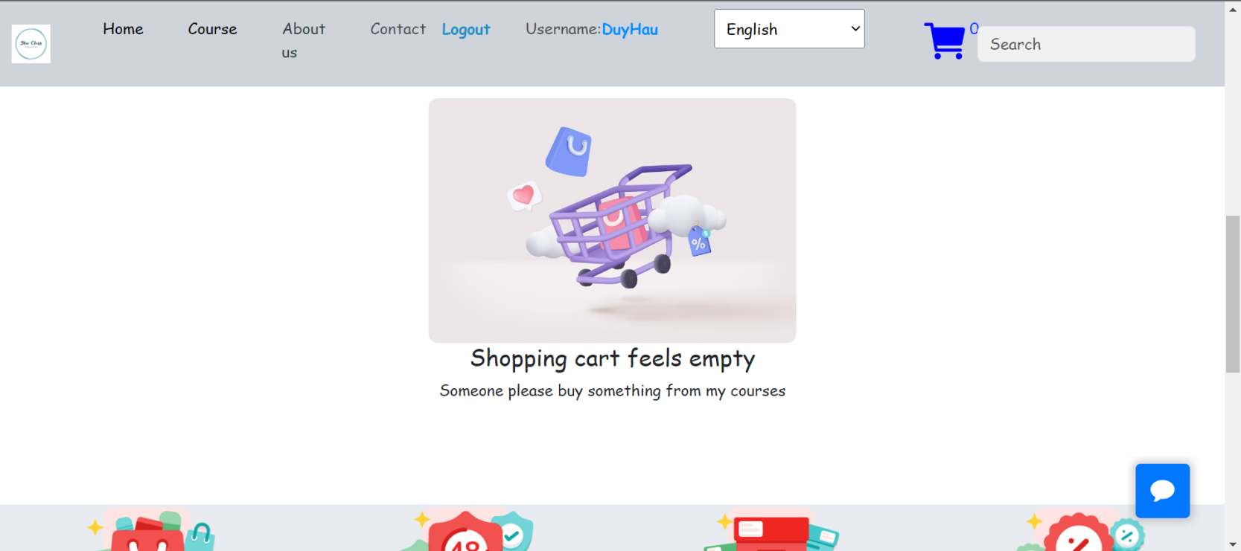

When you add to cart product will display

|  |  |
| --- | --- |
| 42 | Click icon “Trash can” to remove product |
| 43 | Click “Pay Now” to pay our product  If not login and click “Pay Now” will alert “You are not logged in!”  If login and click “Pay Now” will alert “Payment Succes” and then Cart Empty. |

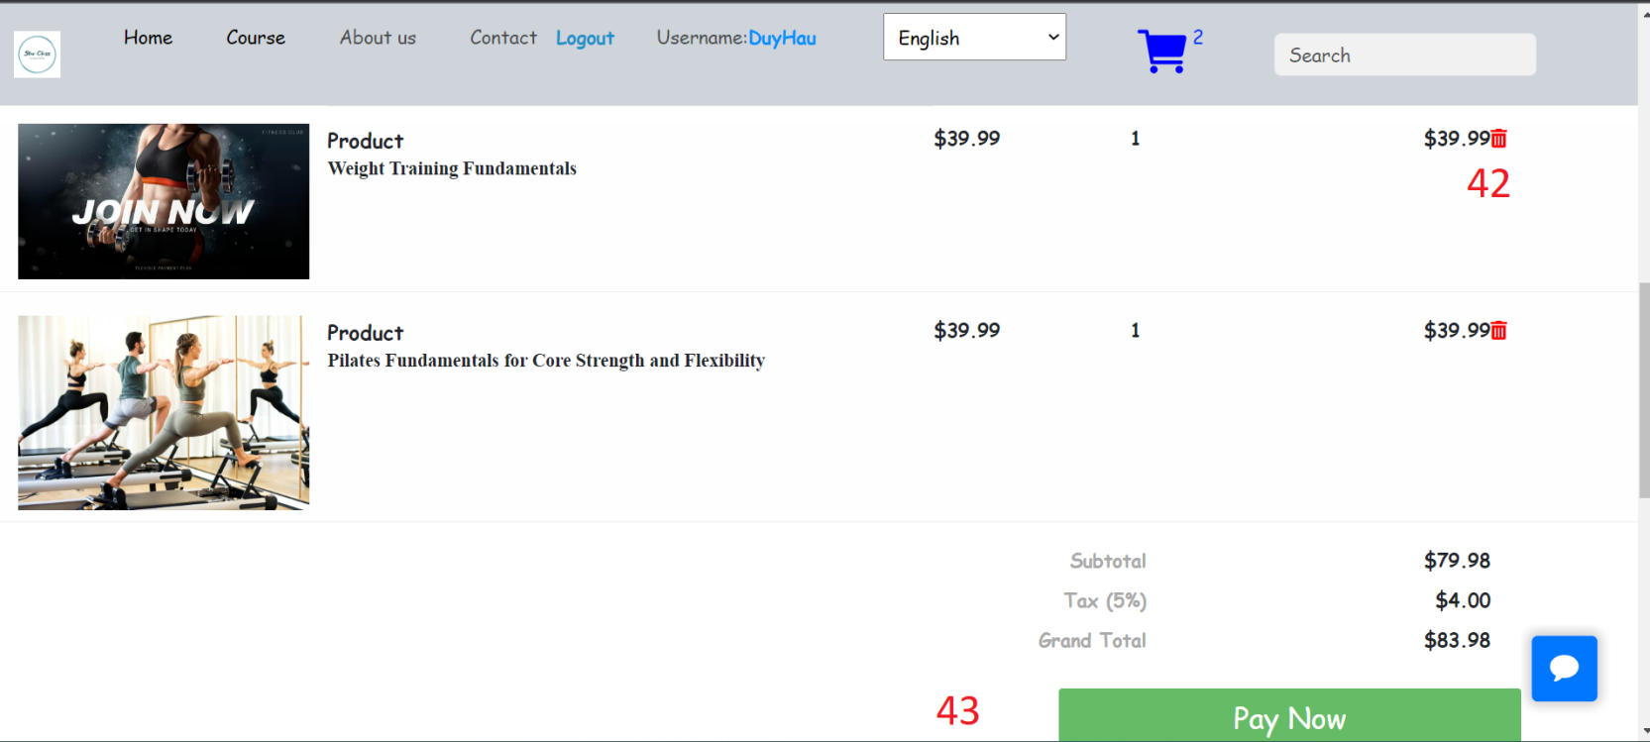

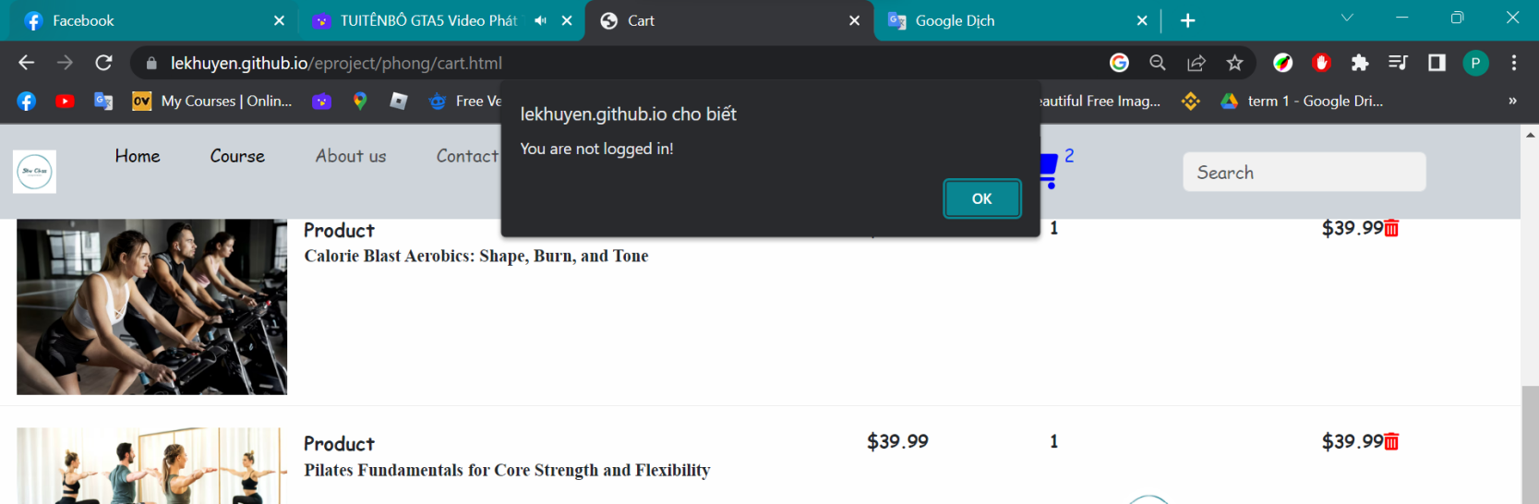

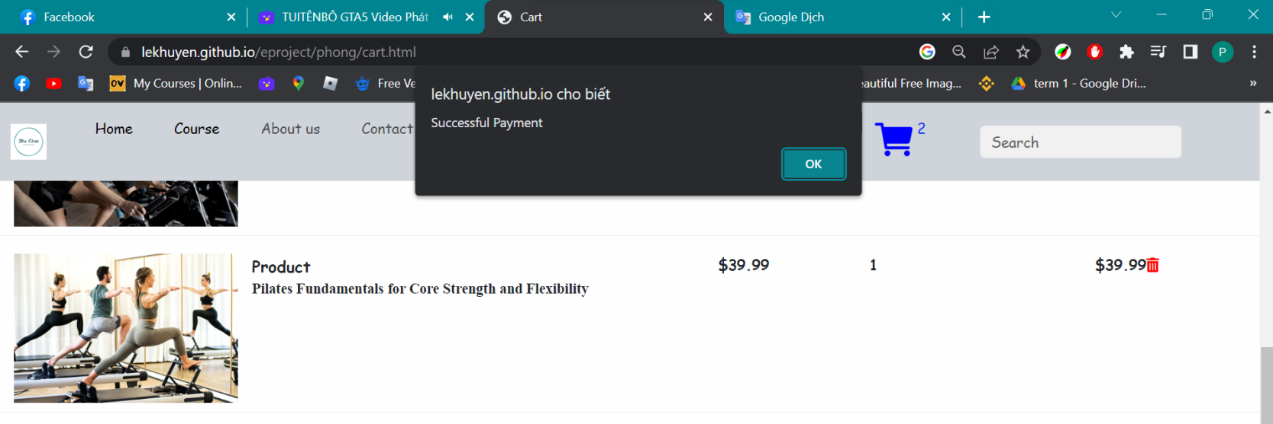

|  |  |  |  |  |  |  |  |
| --- | --- | --- | --- | --- | --- | --- | --- |
| No  Member | Member | Contents | Page Name | Activity Plan | Date of Preparation of  Activity Plan | | |
| Planed Start Date | Actual Start Date | Actual End Date | Status |
| 1 | Phạm Duy Hậu | About us | aboutus.html | 10/5/2023 | 11/5/2023 | 13/5/2023 | 100% |  |
| Contact us | contact.html | 14/5/2023 | 15/5/2023 | 18/5/2023 | 100% |
| Term & Condition | Term &  condition.html | 25/5/2023 | 26/5/2023 | 27/5/2023 | 100% |
| Course | course1.html | 19/5/2023 | 20/5/2023 | 27/5/2023 | 100% |
| 2 | Lê Văn Khuyên | Home | index.html | 10/5/2023 | 11/5/2023 | 18/5/2023 | 100% |
| Course | course1.html | 19/5/2023 | 20/5/2023 | 27/5/2023 | 100% |
| Recruitment | recruitment.html |
| 3 | Trần Thanh Phong | Home | index.html | 10/5/2023 | 11/5/2023 | 18/5/2023 | 100% |
| Course | course1.html | 19/5/2023 | 20/5/2023 | 27/5/2023 | 100% |
| Recruitment | recruitment.html |
| 4 | Giang Lê Phú Thịnh | Login | dangnhap.html | 11/5/2023 | 12/5/2023 | 13/5/2023 | 100% |
| Register | dangky.html | 13/5/2023 | 14/5/2023 | 15/5/2023 | 100% |
| Shopping cart | cart.html | 15/5/2023 | 16/2023 | 17/5/2023 | 100% |